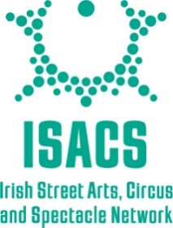

Proud Member of ISACS

The Irish Street Arts Circus and Spectacle (ISACS) Network is a leading example of an artist-first organisation which supports the street, circus and spectacle art forms of Ireland.

Their mission is to celebrate these art forms and advocate for the policy and practical changes that will allow the sector to flourish.

The ISACS values include encouragement and empowerment of their members in their journey, in their professional development and in their creativity. This is achieved through the delivery of a wide range of artistic development programmes, bursaries, residencies, resources and opportunities that ISACS provides for their members.

